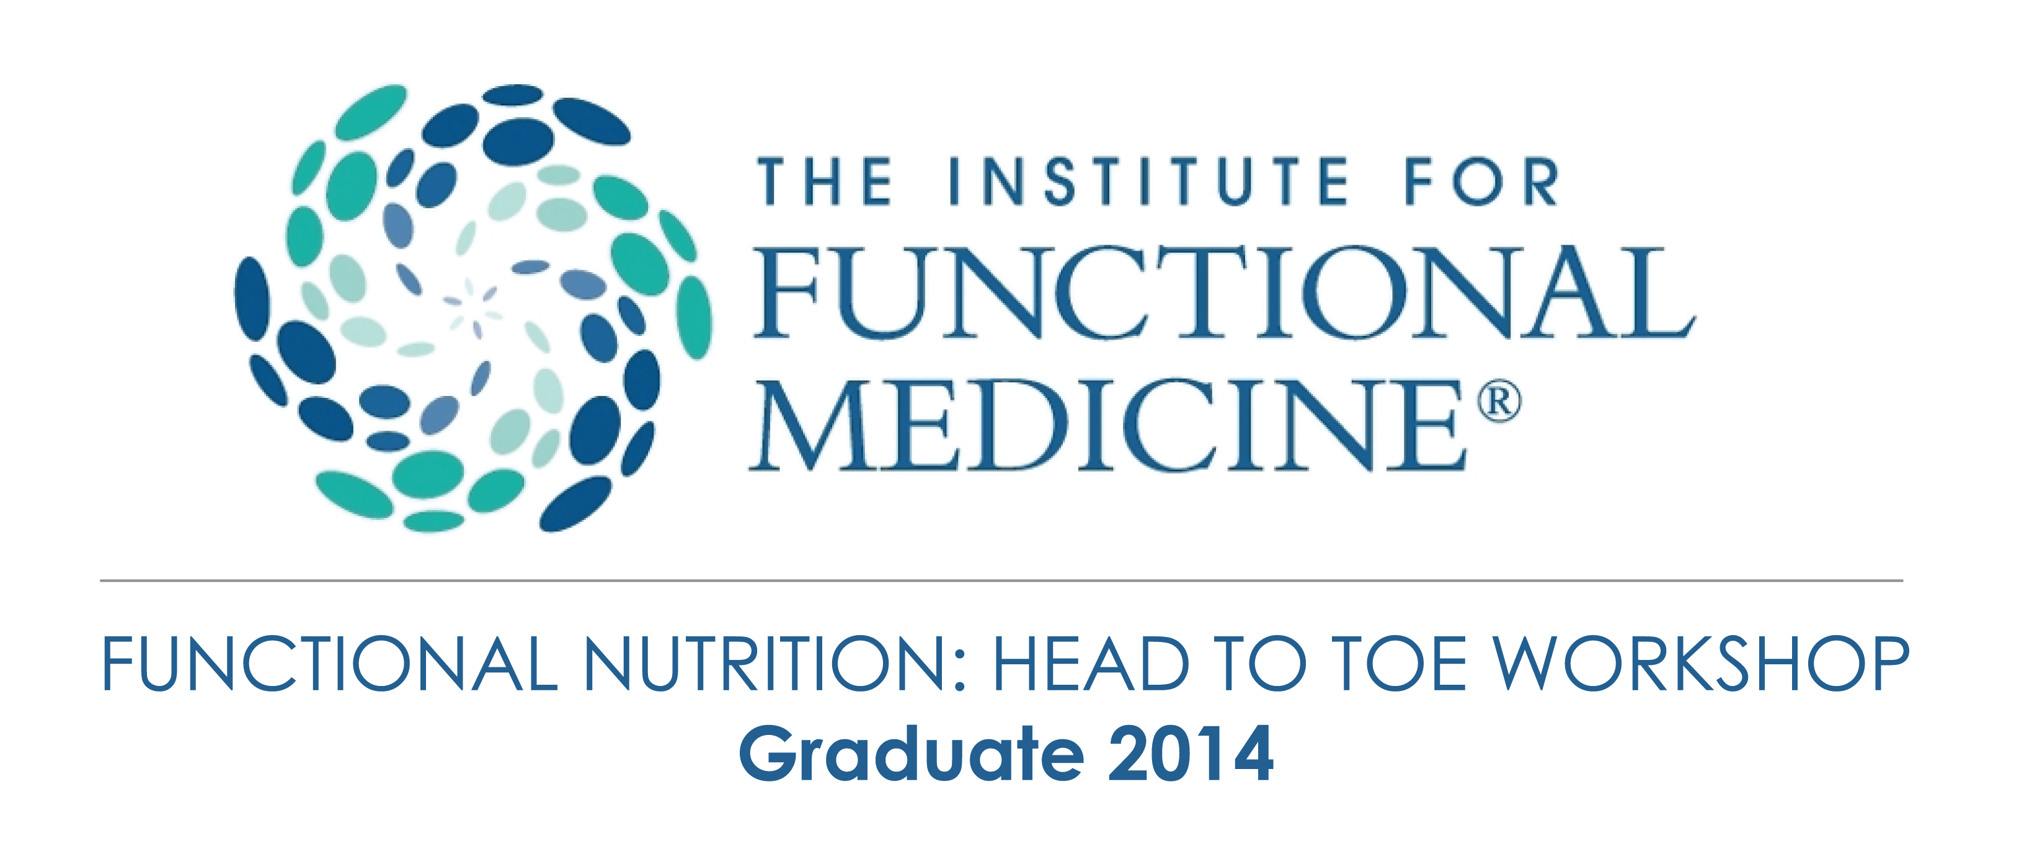

Functional medicine emphasises a definable and teachable process of integrating multiple knowledge bases within a pragmatic intellectual matrix that focuses on functionality at many different levels, rather than a single treatment for a single diagnosis. Functional medicine uses the patient’s story as a key tool for integrating diagnosis, signs and symptoms, and evidence of clinical imbalances into a comprehensive approach to improve both the patient’s environmental inputs and his or her physiological function.

The Institute for Functional Medicine teaches health care professionals how to apply these principles in practice in relation to nutrition physical examination and laboratory analysis through an intensive 2.5 day practice training programme.

I attended and completed the Inaugural Functional Nutrition Workshop training in London in 2014.